**Project: Nappy, the ingenious**

**Team: nappydevelepment**

|  |  |
| --- | --- |
| **Discipline** | **Team member** |
| Business Modeling | Mehmet Ali Incekara |
| Requirements | Marvin Zerulla |
| Analysis and Design | Marvin Zerulla |
| Implementation | nappydevelopment# |
| Test | Manuel Bothner and Mehmet Ali Incekara |
| Deployment | Manuel Bothner |
| Project Management | Mehmet Ali Incekara |
| Environment | Marc Mahler |
| Configuration and Change Managment | Marc Mahler |

#every member of nappydevelopment will implement. More information in the next table.

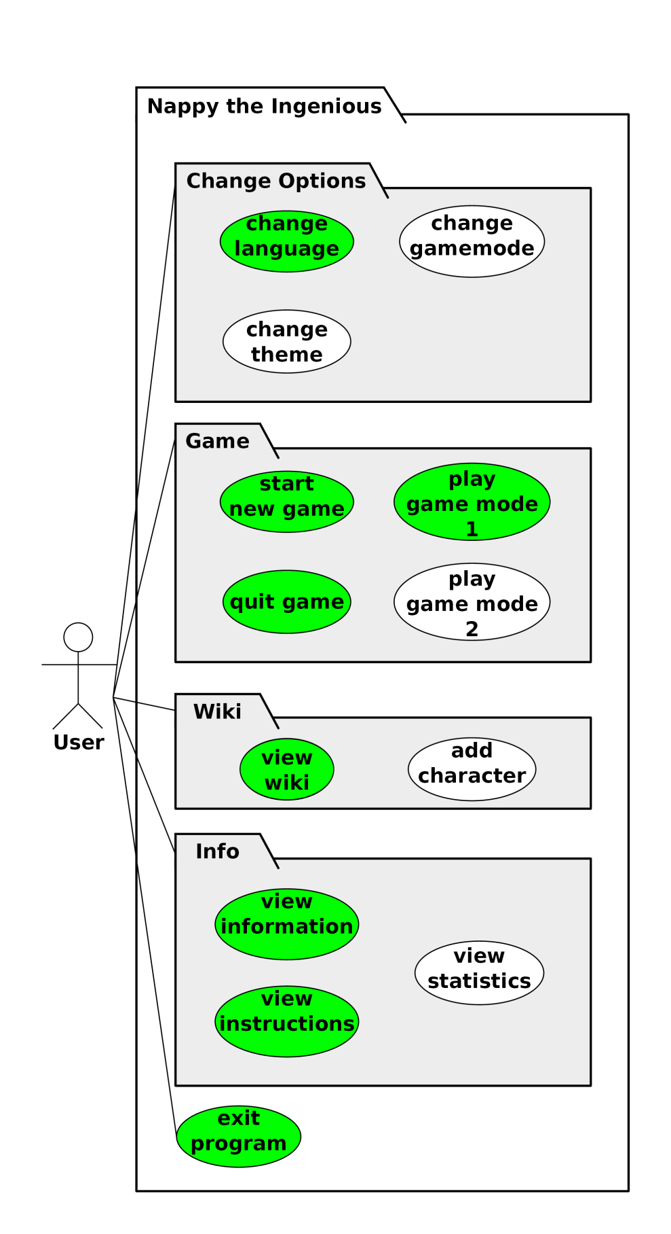

Use-Cases:  
1) Game mode 1   
 (start new game, play game mode 1, quit game)  
2) Change Options  
3) View Wiki  
4) View Instruction  
5) View Info

|  |  |  |
| --- | --- | --- |
| **Zeitraum** | **Kurzbeschreibung** | **Investierte Zeit** |
| **Manuel Bothner** | | |
| 12.10.2015 – 25.10.2015 | Created Demo Program & GUI | 3,5h |
| 24.10.2015 – 25.10.2015 | Mockups | 2,5h |
|  | Create UseCase Change Settings | 0,5h |
| 11.11.2015 – 01.12.2015 | Refactor Demo GUI | 3,5h |
| 11.11.2015 – 25.11.2015 | Refactor to MVC/MVP Concept | 6,5h |
| 30.11.2015 – 06.12.2015 | Implemented GUI (View Info) | 1,5h |
| 20.11.2015 – 21.11.2015 | Implemented Setting: Change Language | 3h |
| 30.11.2015 | Implement GUI (View Instruction) | 1h |
| 30.11.2015 | Implement GUI (View Wiki) | 2h |
| 21.11.2015 | Implement GUI (Change Settings) | 1,5h |
| 11.11.2015 – 14.11.2015 | Implement GUI (MainView) | 6h |
| 16.11.2015 – 19.11.2015 | Implement GUI (Gamemode 1) | 5h |
| 24.11.2015 | Implement GUI (StatisticsView) | 1h |
| 12.10.2015 | Create Package Structure | 0,5h |
| 17.10.2015 | SetUp JavaFX Application | 2h |
| 08.12.2015 | Midterm-Präsentation | 2h |
| **SUMME** | | **41h** |
| **Marc Mahler** | | |
| 01.10.2015 | Charakter Auswahl | 1h |
| 02.11.2015 | Charaktereigenschaften sammeln und dokumentieren | 4h |
| 23.11.2015 – 01.12.2015 | Charakterbeschreibungen | 11h |
|  | UseCase Add Charakter | 2h |
| 09.11.2015 | Planning MVC Concept | 1h |
| 20.10.2015 | Try Gradle | 2h |
| 28.10.2015 – 28.10.2015 | Try Cucumber | 1h |
| 04.11.2015 | Class Diagramm | 4,5h |
| 01.12.2015 | Schreibe Spielanleitung in HTML + CSS | 3h |
| 08.12.2015 | Midterm-Präsentation | 2h |
| **SUMME** | | **31,5h** |
| **Marvin Zerulla** | | |
| 01.12.2015 – 02.12.2015 | characterProvider | 2h |
| 29.11.2015 – 02.12.2015 | databaseProvider | 3,5h |
| 02.12.2015 – 08.12.2015 | questionGenerator | 3,5h |
| 02.10.2015 – 15.10.2015 | Implement Algorithmus für Gamemode 1 | 1h |
| 02.10.2015 – 08.12.2015 | Set Up Database | 2h |
| 02.10.2015 – 12.11.2015 | Schreibe Code Conventions | 3h |
| 06.11.2015 – 24.11.2015 | Zeichne Nappy  (Gamemode 1 und 2 + Logos) | 16,5h |
| 08.12.2015 | Midterm-Präsentation | 2h |
| **SUMME** | | **33,5h** |
| **Mehmet Ali Incekara** | | |
| 01.10.2015 | Charakter Auswahl | 1h |
| 02.10.2015 – 28.10.2015 | Charaktereigenschaften sammeln und dokumentieren | 6h |
| 02.12.2015 | Charakterbeschreibungen | 1h |
| 19.10.2015 – 30.11.2015 | Use-Case Gamemode 1 | 3h |
| 19.10.2015 – 28.10.2015 | Use-Case Gamemode 2 | 2h |
| 21.11.2015 – 30.11.2015 | Use-Case View Wiki | 1,5h |
| 21.11.2015 – 30.11.2015 | Use-Case View Instruction | 1h |
| 21.10.2015 – 30.11.2015 | Use-Case Change Settings | 1h |
| 21.11.2015 – 30.11.2015 | Use-Case View Info | 1h |
| 13.11.2015 – 30.11.2015 | SikuliX Gamemode 1 | 2h |
| 30.11.2015 | SikuliX View Wiki | 0,5h |
| 25.11.2015 – 30.11.2015 | SikuliX View Instruction | 0,5h |
| 13.11.2015 – 30.11.2015 | SikuliX Change Settings | 1h |
| 30.11.2015 | SikuliX View Info | 0,5 |
| 08.11.2015 – 20.11.2015 | SikuliX Gamemode 1 and Change Settings in Java | 5h |
| 28.10.2015 – 05.11.2015 | Try Cucumber | 1h |
| 25.11.2015 | Gantt-Chart | 1,5h |
| 08.10.2015 – 08.12.2015 | Software Requirements Specification | 8h |
| 12.11.2015 – 20.11.2015 | Software Architecture Document | 2h |
| 08.12.2015 | Midterm-Präsentation | 3h |
| **SUMME** | | **43h** |
| **TOTAL** | | **149h (6,2 Tage)** |

*inc. SikuliX, Activity Diagram